
Lesson Plan Prepared for
ARRL Education & Technology Program
Author(s): Nathan McCray | Date: 2003, rev. 2012
Title of Lesson: Understanding Ohms Law | Grade Level: 4 – 12

Core Components

Subject, Content Area or Topic:

Communications, Physics, Electronics, Science, Math

National/State Standards: (Assign as needed based on your state standards)

Common Core Standards: (Assign as needed based on your state requirements)

http://www.corestandards.org/

Vocabulary: (Teacher add as needed based on your curriculum and learning requirements)

Learning Objectives (What will the students learn and/or demonstrate?)

The objective of this lesson is to allow the student to explore, during a simulation, the relationship between the components of electricity (voltage, current, and resistance) using Ohm’s Law.

Materials/Resources
- Four identical cans, large coffee can size. Holes drilled in the side of each can at the bottom of one side. Drill one hole in each coffee can using these common drill sizes: 1/8”, 3/16”, ¼”, /16”, and 3/8”. Smooth edges of drilled holes with a file to prevent possible injury from sharp edges and to ensure flow restriction is due to the hole size, not rough edges.

- Sturdy ring stand or support over a lab sink or plastic tub to hold the cans. The stand should be configured for rapid removal and exchange of different cans.

- Large container of water such as a gallon milk jug that the students can lift and handle to pour water, in a controlled manner, water into the can on the stand. If sinks are available, a steady, controlled stream of water set at the appropriate flow rate that matches the outflow from the can can be used. Some practice will be required to get the right setting of the faucet.

- Small container, like a paper cup, that is marked at a certain level to collect and measure the amount of flow.

- Stopwatches.

- Metric rulers for measuring the depth of water in the can.

Safety (if applicable) NA

Prerequisite Understanding:
- Critical thinking
- Familiarity with volume measurements using SI (System International) units.
- Ability to follow step-by-step procedural instructions.
- Graphing raw data and interpreting graphical presentations for slope and trends.
- Correlate proportional and inversely proportional mathematical trends to graphic displays.

Process Components
Anticipatory Set:
(“The Hook” -- something to excite the student about the subject matter)

Collect a few pictures of electrical labels. Show them on your SMART Board or LCD projector. Ask them what the different letters might mean. For example:

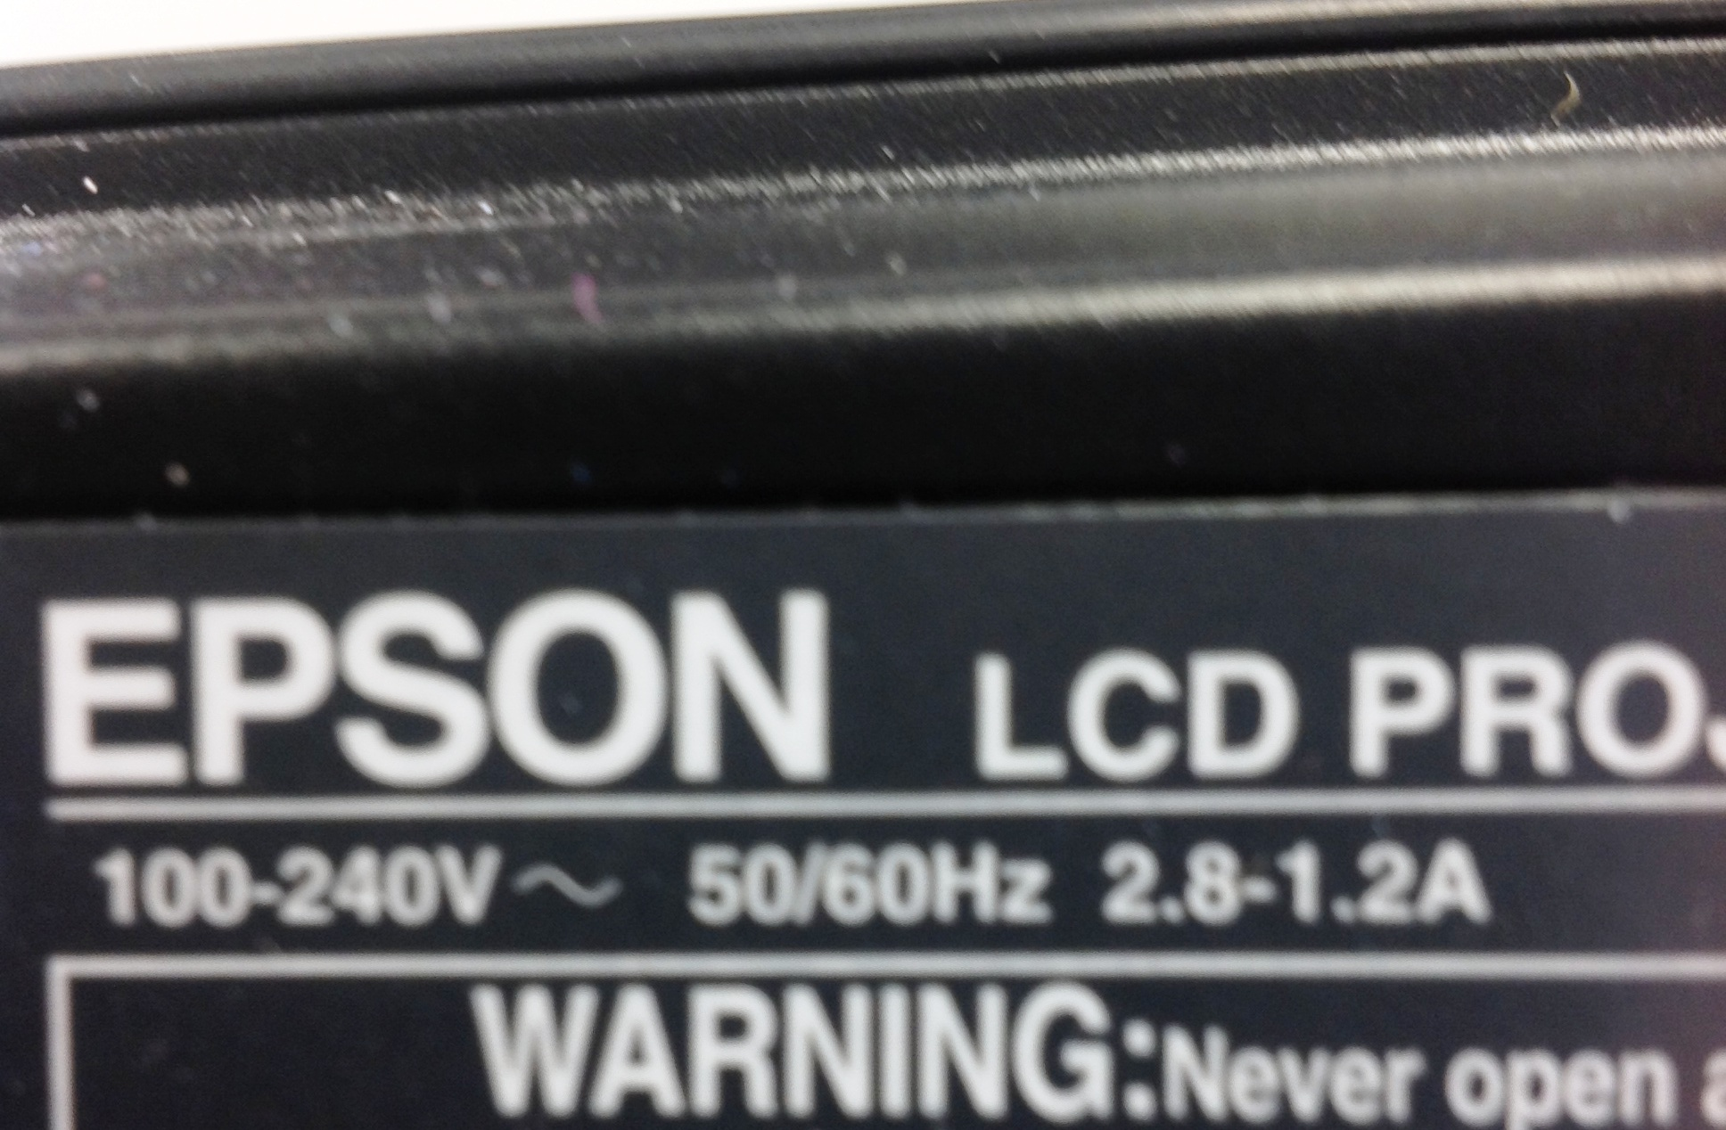

Talk about the meaning of the “V” and the “A” in the pictures and how they might relate.

Instructional Input or Procedure (Input, modeling, and checking for understanding)

Preparation: Before class period set up the stand and the first can to be used in the experiment. Instruct students in how to use the stop watches, how to time the flow, and have the students practice adding water to the can and maintaining the water level in the can at the appropriate level as the water leaks out. Also instruct the students on how to determine the average water depth in the can between two water levels (as measured with a ruler).

Overview: During class discussion use the comparison of electricity and its component parts (voltage, current, and resistance) to water flowing through a hose (the conductor of electricity). The pressure or force pushing the water into one end of the hose is like voltage. Voltage is the electromotive force trying to push electrons through a conduction wire. Electromotive force is one of the fundamental forces or concepts in nature. The water being pushed through the hose is like the current in electricity. The number of electrons flowing in a wire is the definition of current. Finally, water does not flow freely through a hose; there is always some restriction of the flow cause by friction. This is like resistance in electricity, a hindrance of the flow of electrons (current) through a conductor.
In this activity your students will measure the amount of water leaking through a hole (of varying size) in a can, and they will graph the data collected. When they analyze the data collected, they will be able to see a relationship between the heights of the water in the can, the rate the water flows through the hole in the can, and the size of the hole in the can. Finally the students will develop an Ohm’s Law for flowing water which is very similar to Ohm’s Law for electricity.

Guided Practice
What to do and how to do it:

This activity is divided into two parts. Part one simulates constant voltage and seeing the relationship between resistance and current. Part two simulates constant resistance and seeing the relationship between voltage and current.

Part one:

The student team divides the activity tasks between a pourer, timer, flow controller, flow observer, and recorder.

- Students position the first can (with 1/4” hole) on the ring stand. (The team may elect to set up and use the can with the 1/8” hole last because this can will be used for part two of the activity) Position the can over the lab sink or tub so that water can be collected in the measuring cup without undue mess.

- The flow controller places a finger over the hole in the can to stop the flow of water. The pourer fills the can to within 1 cm of the top of the can and replenishes by pouring more water as needed. The timer clears the stopwatch and prepares for data collection. The flow observer positions the measuring cup to collect the flow water. The recorder prepares the data table for entries.

- When the team is ready and positioned for the activity to begin, the flow controller begins the activity by announcing, “go.” At that command the flow controller removes a finger from the hole to allow water to flow. The timer starts the stopwatch. The observer ensures the flow is being collected in the measuring cup and monitors the flow. The pourer begins to slowly replenish the water in the can as it flows out to keep the water level at 1 cm below the top of the can as closely as possible.

- When the flow observer sees that the water in the graduated cylinder has reached the marked volume line, the flow observer commands, “stop.” At that command the timer stops the stopwatch and this portion of the activity is over. The team can relax and record the data in the data table. The data recorded include the hole size and the time between start and stop.

- The team empties the can and removes and replaces the can with the next sized hole. The activity is repeated with each can and the data recorded in the data table.

Part Two:

- The team sets up the apparatus as before, using the can with the 1/8” hole. The ruler will be used in this activity and should be available for making depth measurements. The team may elect to temporarily mount the ruler inside of the can or they may elect to dip the ruler into the can when measurements are required. The team responsibilities can be changed or left as in part one.
- The flow controller places a finger over the hole to prevent water flow. The pourer fills the can up to 1 cm from the top of the can. The recorder records this depth on the data sheet. The timer clears the stopwatch. The flow observer positions the collection cup to collect the flow.
- When the team is set, the flow controller begins the activity by removing a finger from the hole to allow flow and announcing, “go” simultaneously. The timer starts the stopwatch. The flow observer ensures the flow is entering the measuring cup.

- When designated water has been collected in the measuring cup (the water level has reached the designated mark), the flow observer commands “stop.” The flow controller places a finger over the hole to stop the water flow. The timer stops the stopwatch, announces the elapsed time, and clears the stopwatch for the next collection. The pourer measures the new depth of water in the can. The recorder records the elapsed time and the depth on the data sheet in two places.

- The intermediate depth is the ending depth measurement on one line of the data sheet and the starting depth for the next line. The depth should be measured to the nearest millimeter. Note: the water in the can is NOT replenished in this part of the activity.

- The team repeats the activity until the water in the can has been depleted.

Independent Practice

The students create two graphs using the appropriate scaling that makes a meaningful presentation of the data. For part one, the Y-axis of the graph would be the inverse of the time of flow, with the lowest value at the origin of the Y-axis. The X-axis of the graph would be the size of the hole (either the diameter or the area of the hole area) would be the more appropriate axis parameter. For part two, the Y-axis of the graph would be the average depth of the water in the can for each data collection (starting depth and ending depth divided by 2). The X-axis of the graph would be the inverse of the time of flow.

Assessment/Closure

Assessment (Pre, post etc…)

Activity questions:

- From your observations and the depiction of the data on the graph from part one; describe in a few sentences the relationship between the rate of flow of the water (current) to the size of the hole (resistance). How is this relationship communicated through the mathematical formula for Ohm’s Law?

- From your observations and the depiction of the data on the graph from part two, describe in a few sentences the relationship between the height of the water in the can (voltage) to the flow of the water (current). Does the mathematical formula for Ohm’s Law communicate this relationship?

- Can you devise an activity to explore the concept of keeping the flow rate constant (constant current) and seeing the relationship between the height of the water in the can (voltage) and the hole size (resistance)?

Enrichment:
- Explain the similarity between hole area and resistance. Why is, or why isn’t this comparison more valid than comparing hole diameter to resistance?

- The relationships depicted by Ohm’s Law are linear; the data presented from this activity is not linear. Why is the data not linear? Is the comparison valid or invalid? What can be changed in the activity to make the outcome more linear, and therefore the comparison more valid?

- Would this activity be as capable of simulating Ohm’s Law if you used a thicker, more viscous, liquid such as motor oil? Why or why not?

- Using the data collected, predict the outcome of repeating the activity with hole sizes larger and smaller than those used. Then conduct the activity again with those different hole sizes and verify your predications.

- Would this activity be valid if very low or very high flow rates were used (very small/very large holes)? Explain why or why not.

Resources/References

Ham Radio License Manual Pg 10.2

ARRL Handbook Pg 3.1

Understanding Basic Electronics Chapter 11

http://www.arrl.org/files/file/ETP/The%205%20Building%20Blocks%20activity%20board%202_3.pdf

*Every lesson is different so you may not have to fill in all areas.

Notes:

Adaptations for special needs:

Hearing impaired students should be able to fully participate in this activity without major modification. Hand signals for start/stop commands may have to be substituted for verbal commands. Visually impaired students can participate at appropriate positions within the team without activity modifications. Simple audio fluid level sensors could be added to the equipment list to allow full access to all positions on the team.

